Name: Arpit Mahalle
Day 18 Assessment output screenshots

Challenge 7
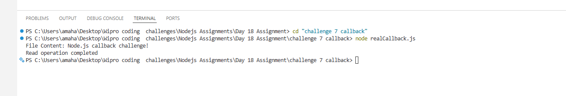

This screenshot shows the callback-based file read working successfully, printing the file content. After a short delay, it confirms completion with “Read operation completed.”
--------------------------------------------------------------------------------------------------------------
Challenge 8
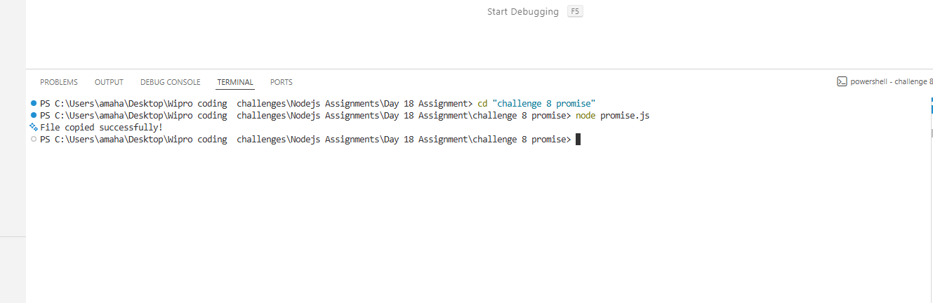

This screenshot shows the Promise-based code running and confirming that the file was copied successfully. The process completed without errors, and “output.txt” was created automatically.
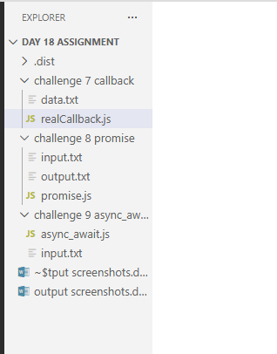

This screenshot displays the folder structure for Challenge 8, showing input.txt, promise.js and the newly generated output.txt. The presence of output.txt confirms the Promise-based file copy worked correctly.
----------------------------------------------------------------------------------------------------------------
Challenge 9
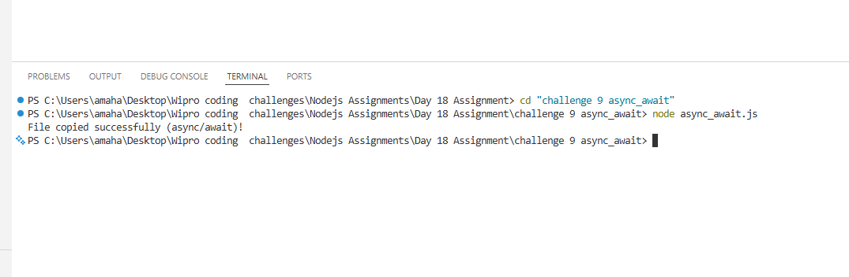

This screenshot shows the async/await version successfully copying the file.
After the artificial delay, it prints “File copied successfully (async/await)!”

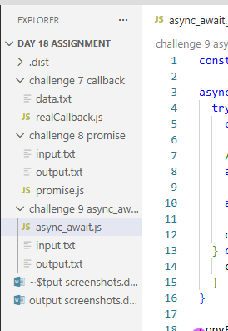

This screenshot shows the Challenge 9 folder, containing the script, input file, and auto-created output.txt. It confirms that async/await logic executed properly and generated the copied file.

